For Collinsville Canoe & Kayak Use Only CONSIGNMENT#:
SOLD (To be assigned by CCK at drop off)
NOT SOLD Today’s Date: Click here to enter a date.
PICKED UP

Customer’s Name: Click here to enter text.
Mailing Address: Click here to enter text.
City: Click here to enter text. State: Click here to enter text. Zip Code: Click here to enter text.
E-Mail Address: Click here to enter text.
Telephone Number: Click here to enter text.
Boat or Board Make & Model: Click here to enter text. Serial #: Click here to enter text.
Sorry, we do not accept kit, folding boats, inflatables or accessories. Please bring boats/boards clean and ready to sell (no missing parts).
We reserve the right to turn away boats/boards that are unsafe, worn out or dirty.
Saturday Price: Sunday Price:
To be determined at drop off. Collinsville Canoe & Kayak is happy to help you price your boat or board at drop off.
Terms: CHECK ONE: ☐90% Store Credit or ☐70% Store Check
**A non-refundable $10 (cash) per boat handling fee is required at time of drop off. **
Customer’s Signature:

You’ve been assigned Consignment #:
Terms of Consignment: By signing this consignment form, I agree to pick up my unsold merchandise by 5:00 pm on the Sunday of the sales event. Prior to the pickup date, it is my responsibility to contact Collinsville Canoe & Kayak to determine whether or not the merchandise described above has been sold. If I choose to receive a store check for my sold merchandise, I will be issued a check no later than 30 days from the date of sale. Store credit cannot be transferred to store check at a later date. Collinsville Canoe & Kayak will make every effort to protect the condition of your boat but will not be liable for damages to any boat which is part of the consignment sale. Please present this form when picking up an unsold consignment boat.

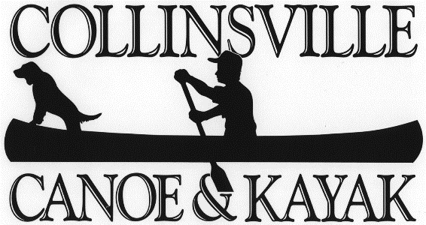

41 Bridge Street PO Box 336 Collinsville, CT 06022
(860) 693-6977 www.collinsvillecanoe.com

